CPE301 – FALL 2019

Final/Midterm II

Student Name: Brysen Kokubun

Student #: 2001009068

Student Email: brysenkokubun96@gmail.com

Primary Github address: https://github.com/bkokubun99/Submission_DesignAssignments

Directory: <https://github.com/bkokubun99/Submission_DesignAssignments/tree/master/Final>

1. **COMPONENTS LIST AND CONNECTION BLOCK DIAGRAM w/ PINS**

* Atmel Studio 7.0
  + Assembler
  + Simulator
  + Debugger
  + Terminal
* Atmega328PB-XminiPC
* APDS9960 Sensor
* ESP-015 Module
* FTDI232 (External 3.3V Source)
* ThingSpeak

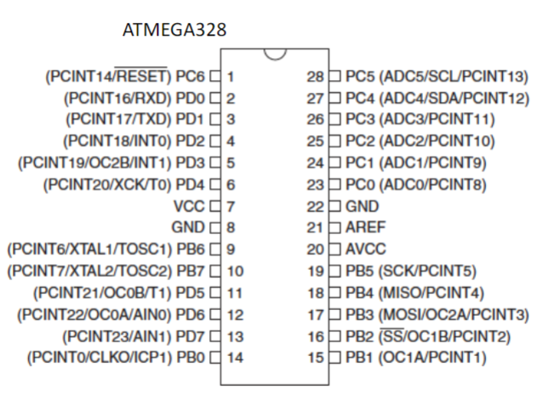

1. **INITIAL/MODIFIED/DEVELOPED CODE OF TASK 1/A**

/*

* Final.c

*

* Created: 12/9/2019 4:56:10 PM

* Author : Brysen Kokubun

*/

/******************************************************************************

* Definitions *

******************************************************************************/

//Frequency Definitions

#ifndef F_CPU

#define F_CPU 16000000UL

#endif

//UART Definitions

#define BAUD 9600

#define FOSC 16000000

#define UBRR FOSC/8/BAUD-1

//Sensor Write & Read Definitions

#define APDS9960_WRITE 0x72

#define APDS9960_READ 0x73

/******************************************************************************

* Libraries *

******************************************************************************/

#include <avr/io.h>

#include <stdlib.h>

#include <stdio.h>

#include <util/delay.h>

#include <math.h>

#include "uart.h" //Header Files From Dr. Venki

#include "APDS9960_def.h" //Header Files From Dr. Venki

#include "i2c_master.h" //Header Files From Dr. Venki

/******************************************************************************

* Function Prototypes *

******************************************************************************/

void USART_init();

void init_APDS9960(void);

void USART_tx_string(volatile unsigned char *data);

void ReadSensor(void);

/******************************************************************************

* Global Variable Declarations *

******************************************************************************/

volatile unsigned char RED[10]; //Array to store Red String Value

volatile unsigned char GREEN[10]; //Array to store Green String Value

volatile unsigned char BLUE[10]; //Array to store Blue String Value

*uint16_t* RedData; //Int Variable For Color Red

*uint16_t* GreenData; //Int Variable For Color Green

*uint16_t* BlueData; //Int Variable For Color Blue

/******************************************************************************

* AT Commands Declarations *

******************************************************************************/

//Test Connection

volatile unsigned char AT[] = "AT\r\n";

//Set Wi-Fi Connection Mode

volatile unsigned char CWMODE[] = "AT+CWMODE=3\r\n";

//Retrieve Wi-Fi Information for Connection

volatile unsigned char CWJAP[] = "AT+CWJAP=\"Wifi\",\"Password\"\r\n";

//Enable Connection

volatile unsigned char CIPMUX[] = "AT+CIPMUX=0\r\n";

//Connect With ThingSpeak Through IP Address

volatile unsigned char CIPSTART[] = "AT+CIPSTART=\"TCP\",\"184.106.153.149\",80\r\n";

//Set Send Function Size To 125

volatile unsigned char CIPSEND[] = "AT+CIPSEND=125\r\n";

//Retrieve API Key To Write To ThingSpeak

volatile unsigned char API[] = "GET /update?key=BTGT7XH3A9N1Y80Z&field1=";

//Field 2 String

volatile unsigned char F2[] = "&field2=";

//Field 3 String

volatile unsigned char F3[] = "&field3=";

//Reset The Module

volatile unsigned char RESET[] = "AT+RST\r\n";

//Close

volatile unsigned char CLOSE[] = "AT+CIPCLOSE\r\n";

/******************************************************************************

* Int Main *

******************************************************************************/

int main(void){

USART_init(); //Initialize UART

i2c_init(); //Initialize I2C

init_APDS9960(); //Initialize APDS9960 Sensor

*_delay_ms*(5000);

USART_tx_string(AT); //Test Connection

*_delay_ms*(500);

USART_tx_string(RESET); //Reset The Module

*_delay_ms*(500);

USART_tx_string(AT); //Confirm Connection

*_delay_ms*(500);

USART_tx_string(CWMODE); //Set Wi-Fi Connection Mode

*_delay_ms*(500);

USART_tx_string(CWJAP); //Retrieve Wi-Fi Information

*_delay_ms*(500);

while(1){

*_delay_ms*(1000);

USART_tx_string(CIPMUX); //Enable Connection Point

*_delay_ms*(1000);

USART_tx_string(CIPSTART); //Connect To ThingSpeak

*_delay_ms*(10000);

USART_tx_string(CIPSEND); //Send Size Set To 125

*_delay_ms*(1000);

ReadSensor(); //Retrieve Sensor Values

USART_tx_string(API); //Connect To API Key

USART_tx_string(RED); //Send ADC Sensor Value To Field 1

USART_tx_string(F2);

USART_tx_string(GREEN); //Send ADC Sensor Value To Field 2

USART_tx_string(F3);

USART_tx_string(BLUE); //Send ADC Sensor Value To Field 3

*_delay_ms*(1000);

}

return 0;

}//End Main

/******************************************************************************

* Function Declarations *

******************************************************************************/

//Function To Initialize USART

void USART_init()

{

UBRR0H = ((UBRR) >> 8);

UBRR0L = UBRR;

UCSR0A |= (1<< U2X0);

UCSR0B |= (1 << TXEN0); //Transmission Enable

UCSR0C |= (1 << UCSZ01) | (1 << UCSZ00); //8-Bit Data

}

//Function To Initialize APDS9960 Sensor

void init_APDS9960(void)

{

*uint8_t* setup;

i2c_readReg(APDS9960_WRITE, APDS9960_ID, &setup,1);

if(setup != APDS9960_ID_1) while(1);

setup = 1 << 1 | 1<<0 | 1<<3 | 1<<4;

i2c_writeReg(APDS9960_WRITE, APDS9960_ENABLE, &setup, 1);

setup = DEFAULT_ATIME;

i2c_writeReg(APDS9960_WRITE, APDS9960_ATIME, &setup, 1);

setup = DEFAULT_WTIME;

i2c_writeReg(APDS9960_WRITE, APDS9960_WTIME, &setup, 1);

setup = DEFAULT_PROX_PPULSE;

i2c_writeReg(APDS9960_WRITE, APDS9960_PPULSE, &setup, 1);

setup = DEFAULT_POFFSET_UR;

i2c_writeReg(APDS9960_WRITE, APDS9960_POFFSET_UR, &setup, 1);

setup = DEFAULT_POFFSET_DL;

i2c_writeReg(APDS9960_WRITE, APDS9960_POFFSET_DL, &setup, 1);

setup = DEFAULT_CONFIG1;

i2c_writeReg(APDS9960_WRITE, APDS9960_CONFIG1, &setup, 1);

setup = DEFAULT_PERS;

i2c_writeReg(APDS9960_WRITE, APDS9960_PERS, &setup, 1);

setup = DEFAULT_CONFIG2;

i2c_writeReg(APDS9960_WRITE, APDS9960_CONFIG2, &setup, 1);

setup = DEFAULT_CONFIG3;

i2c_writeReg(APDS9960_WRITE, APDS9960_CONFIG3, &setup, 1);

}

//FUNCTION THAT READS IN 1 CHAR AT A TIME

void USART_tx_string(volatile unsigned char *data)

{

//CONTROL ENTERS WHILE DATA REG NOT EMPTY

while((*data!='\0'))

{

//WAIT FOR BUFFER REGISTER TO CLEAR

while(!(UCSR0A & (1 << UDRE0)));

UDR0 = *data; //REGESTER EQUALS DATA

data++; //DATA MOVES POSITION

}

}

//Function That Reads The APDS9960 Sensor And Stores Color Values

void ReadSensor(void)

{

//Variables To Store Color's(High/Low) Values

*uint8_t* RedHi, RedLo;

*uint8_t* GreenHi, GreenLo;

*uint8_t* BlueHi, BlueLo;

//I2C Read Function To Retrieve Red(High/Low) Values

i2c_readReg(APDS9960_WRITE, APDS9960_RDATAH, &RedHi, 1);

i2c_readReg(APDS9960_WRITE, APDS9960_RDATAL, &RedLo, 1);

//I2C Read Function To Retrieve Green(High/Low) Values

i2c_readReg(APDS9960_WRITE, APDS9960_GDATAH, &GreenHi, 1);

i2c_readReg(APDS9960_WRITE, APDS9960_GDATAL, &GreenLo, 1);

//I2C Read Function To Retrieve Blue(High/Low) Values

i2c_readReg(APDS9960_WRITE, APDS9960_BDATAH, &BlueHi, 1);

i2c_readReg(APDS9960_WRITE, APDS9960_BDATAL, &BlueLo, 1);

//Shift The High Value by 8 and Combine With Low Value

RedData = (RedHi << 8) | RedLo;

GreenData = (GreenHi << 8) | GreenLo;

BlueData = (BlueHi << 8) | BlueLo;

//Make Sure The Sensor Values Do Not Exceed 255

if (RedData > 255)

{

RedData = 255;

}

if (GreenData > 255)

{

GreenData = 255;

}

if (BlueData > 255)

{

BlueData = 255;

}

unsigned char i;

char temp[10];

//Convert Char To ASCII

*itoa*(RedData, temp, 10);

for(i = 0 ; i < 10 ; i++)

{

RED[i] = temp[i];

}

//Convert Char To ASCII

*itoa*(GreenData, temp, 10);

for(i = 0 ; i < 10 ; i++)

{

GREEN[i] = temp[i];

}

//Convert Char To ASCII

*itoa*(BlueData, temp, 10);

for(i = 0 ; i < 10 ; i++)

{

BLUE[i] = temp[i];

}

}

1. **DEVELOPED MODIFIED CODE OF TASK 2/A from TASK 1/A**

**N/A**

1. **SCHEMATICS**

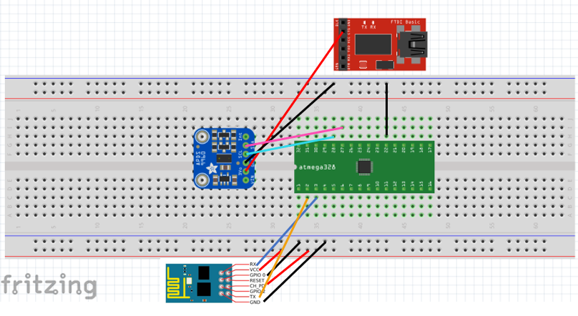

Connect To USB-Port For 3.3V ForffffffssasasCCConnection

1. **SCREENSHOTS OF EACH TASK OUTPUT (ATMEL STUDIO OUTPUT)**

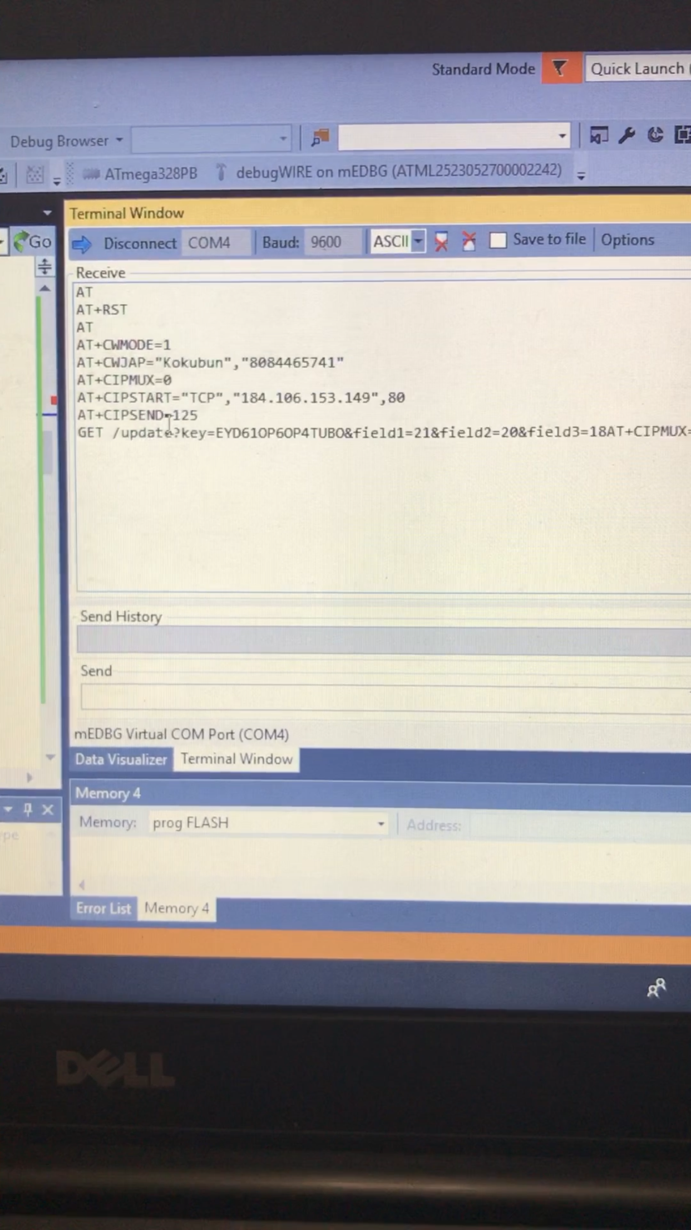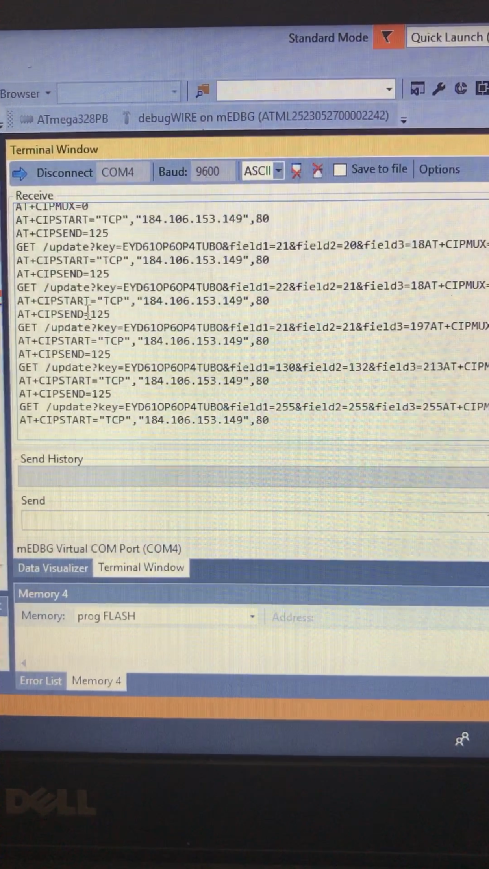

Field Values 1, 2, 3, Change When Light Hits the Sensor

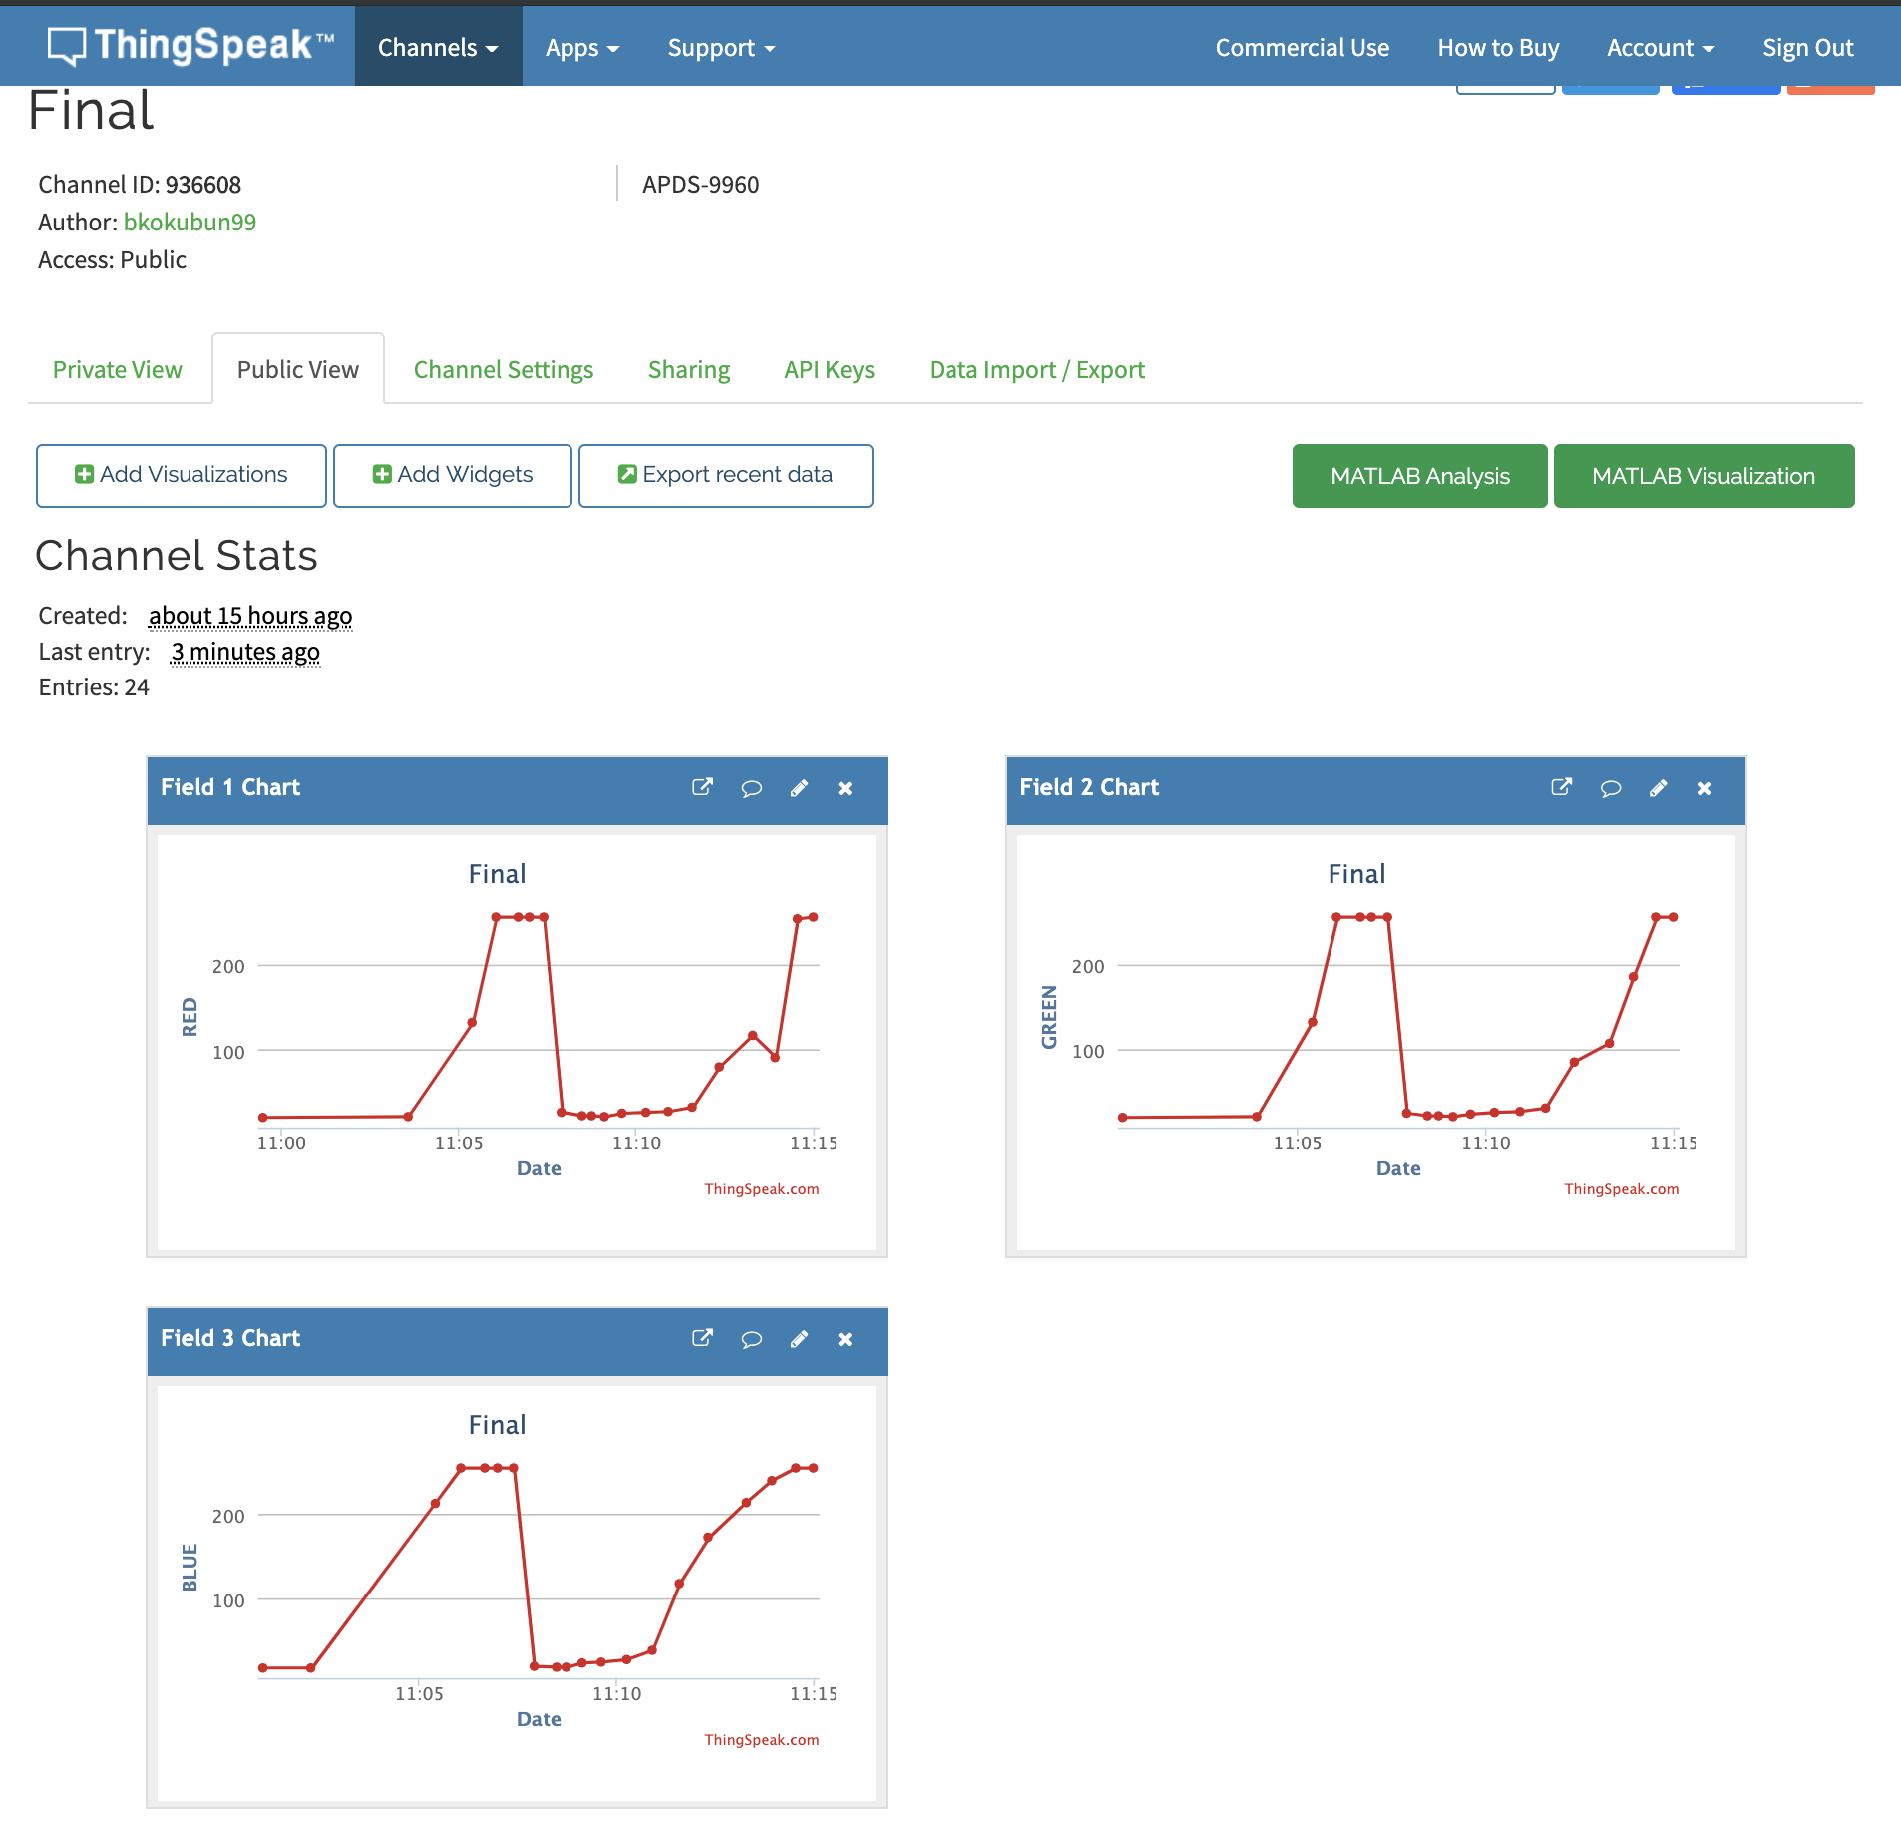

1. **SCREENSHOT OF EACH DEMO (BOARD SETUP)**

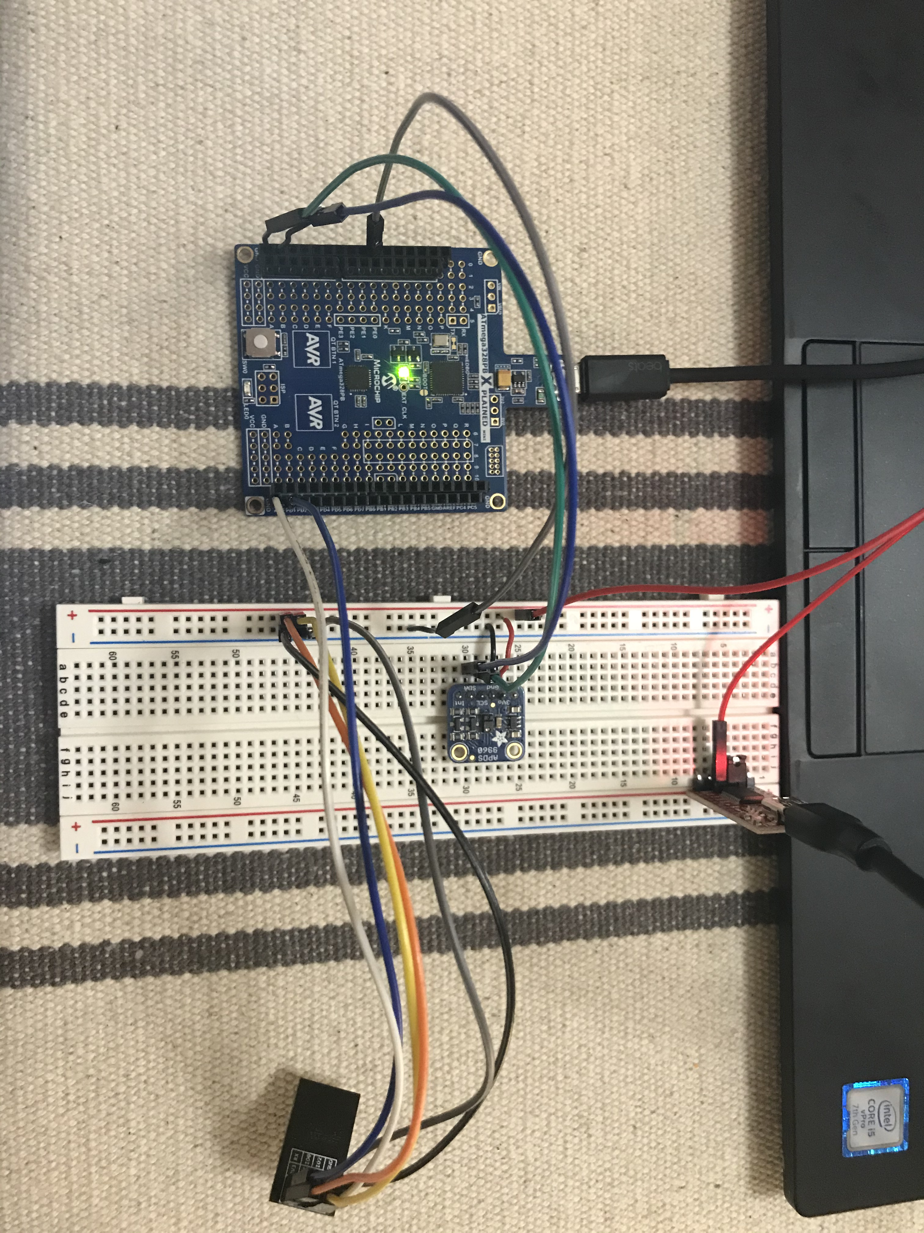

1. **VIDEO LINKS OF EACH DEMO**

YouTube Video Demo - <https://youtu.be/SZtxrwHFLMY>

|  |
| --- |
|  |

1. **GITHUB LINK OF THIS DA**

<https://github.com/bkokubun99/Submission_DesignAssignments/tree/master/Final>

**Student Academic Misconduct Policy**

<http://studentconduct.unlv.edu/misconduct/policy.html>

“This assignment submission is my own, original work”.

Brysen Kokubun